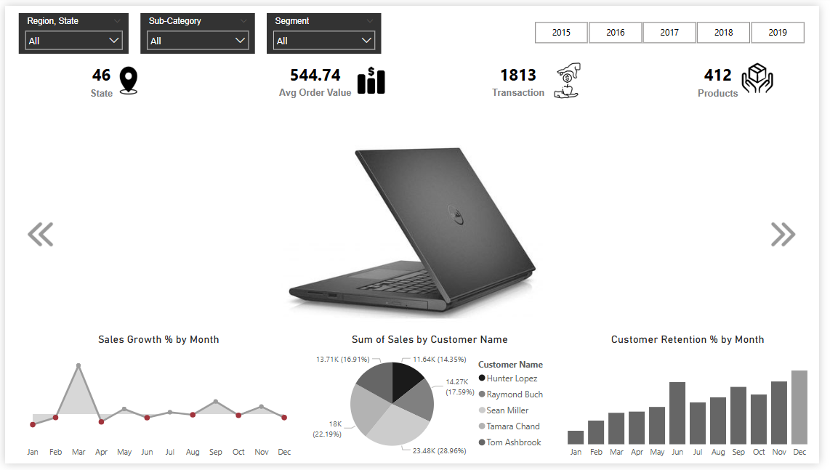

Data Visualization

Technology Category Performance Overview

Furniture Category Performance Overview

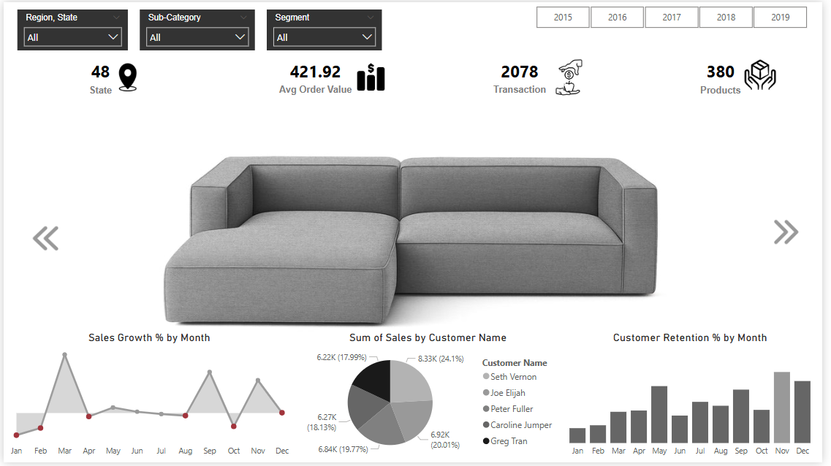

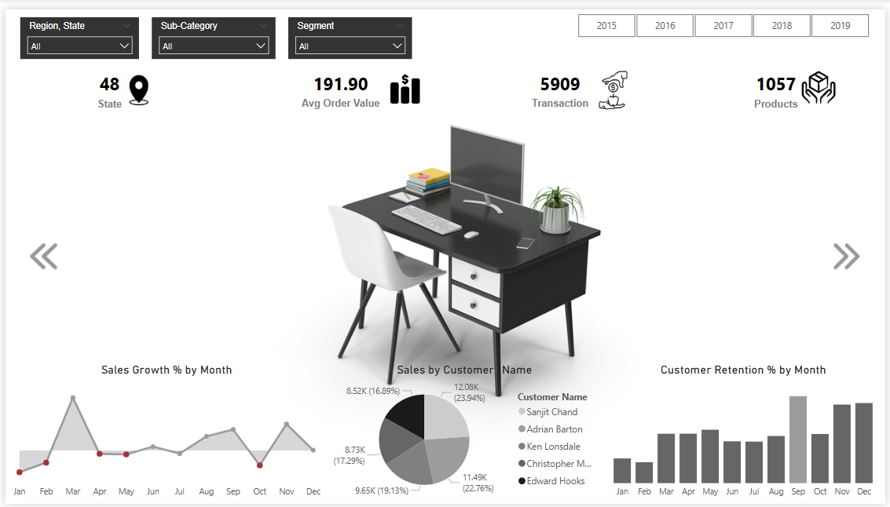

Office Supplies Category Performance Overview

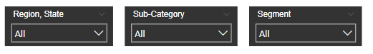

🔧 **1. Filter Controls (Slicers)**

| **Filter Name** | **Type** | **Description** |
| --- | --- | --- |
| **Region, State** | Dropdown | Allows users to filter the entire dashboard by state within a region. |
| **Sub-Category** | Dropdown | Enables filtering by specific product sub-categories (e.g., Chairs, Phones). |
| **Segment** | Dropdown | Filters data based on customer segments (Consumer, Corporate, Home Office). |



📌 **2. KPI Indicator Cards**

| **Metric** | **Value(Example)** |  |  |  | **Description** |  |  |  |  |
| --- | --- | --- | --- | --- | --- | --- | --- | --- | --- |
| **State** | 46 |  |  |  | Total number of unique U.S. states involved in transactions. |  |  |  |  |
| **Avg Order Value** | 544.74 |  |  |  | Average value per transaction, calculated as Total Sales / Total Orders. |  |  |  |  |
| **Transaction** | 1813 |  |  |  | Total count of individual orders or sales transactions. |  |  |  |  |
| **Products** | 412 |  |  |  | Number of unique products sold. |  |  |  |  |



📅 **3. Year Filter Buttons**

| **Year Range** | **Description** |
| --- | --- |
| 2015–2019 | Allows dynamic filtering by year to review historical data trends. |

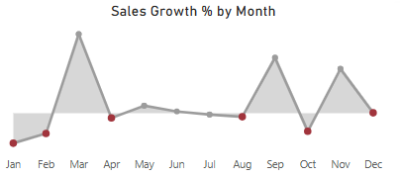

📊 **4. Visualizations Overview**

### A. **Sales Growth % by Month** (Line Chart)

* **Purpose:** Shows the **month-over-month sales growth rate**.
* 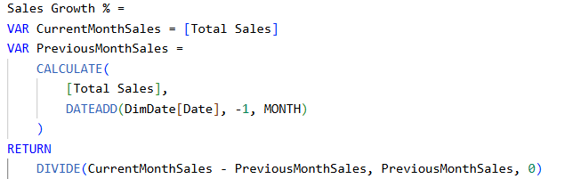**Metric Logic:**
* **Insight:** Useful to track seasonality or promotional impact.

### 

### B. **Sum of Sales by Top 5 Customer Name** (Pie Chart)

* **Purpose:** Highlights top customers by total sales contribution.
* **Metric Used:**

Total Sales=∑(Sales(

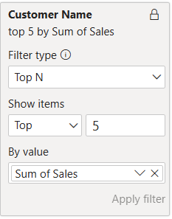

* **Insight:** Identifies key clients driving revenue.

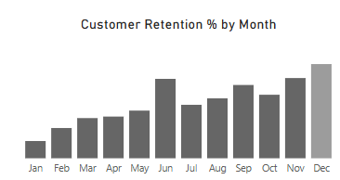

### C. **Customer Retention % by Month** (Bar Chart)

* **Purpose:** Measures customer retention trends monthly.
* **Metric Logic:**

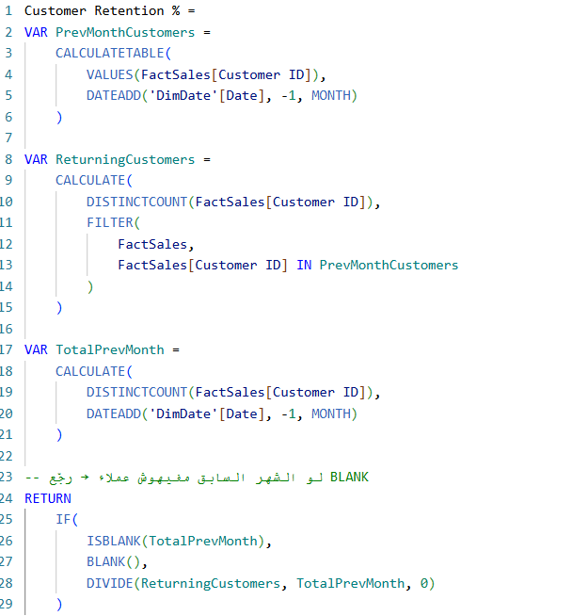

* **Insight:** Tracks engagement and loyalty over time. May indicate churn risk or effective re-engagement campaigns.

**📊 Key Insights from the Dashboard (Technology Category)**

1. **Geographic Coverage**
   * This category covers **46 different states**, indicating a wide national reach.
2. **Sales Performance Metrics**
   * **Average Order Value (AOV)** is **$544.74**, which reflects a healthy transaction size in the tech category.
   * A total of **1813 transactions** were recorded, which provides a reasonable volume for trend and customer behavior analysis.
3. **Product and Customer Metrics**
   * There are **412 unique products**, suggesting a diverse portfolio within the technology segment.
   * **Top customers by sales** include **Sean Miller (28.96%)**, followed by **Tamara Chand (22.19%)** and others, showing high concentration of sales among a few key customers.
4. **Monthly Sales Growth (%)**
   * A noticeable spike in **March**, followed by relatively flat performance throughout the rest of the year. This could indicate seasonality or a one-time promotional effect.
5. **Customer Retention (%) by Month**
   * Retention rates **increase steadily** throughout the year, peaking in **December**, which suggests successful long-term engagement or a strong end-of-year sales push.

**📌 Strategic Recommendations**

1. **Diversify Customer Base**
   * Sales are heavily concentrated among a few customers. Reduce dependency on top clients by:
     + Expanding into new customer segments.
     + Creating loyalty programs to retain and grow smaller clients.
2. **Capitalize on High Retention Periods**
   * Since retention is highest in Q4:
     + Implement targeted marketing campaigns and promotions during Q3 to maximize Q4 retention benefits.
     + Launch upselling or renewal campaigns in October–December.
3. **Investigate March Sales Spike**
   * Analyze what caused the significant growth in March (e.g., promotions, new product launches, or industry events) and replicate successful strategies in other months.
4. **Review Product Portfolio**
   * With 412 products, assess product-level profitability and eliminate underperformers to streamline inventory and improve ROI.
5. **Enhance Regional Strategy**
   * Analyze performance by state to identify underperforming regions and tailor marketing or logistics strategies accordingly.

📊 **Key Insights from the Dashboard (Furniture Category)**

1. **Geographic Coverage**
   * This category covers **48 different states**, indicating a wide national reach.
2. **Sales Performance Metrics**
   * **Average Order Value (AOV)** is **$421.92**, which reflects a healthy transaction size in the tech category.
   * A total of **2078 transactions** were recorded, which provides a reasonable volume for trend and customer behavior analysis.
3. **Product and Customer Metrics**
   * There are **380 unique products**, suggesting a diverse portfolio within the technology segment.
   * **Top customers by sales** include **Seth Vemon (24.1%)**, followed by **Joe Elijah (20.01%)** and others, showing high concentration of sales among a few key customers.
4. **Monthly Sales Growth (%)**
   * A noticeable spike in **March**, followed by relatively flat performance throughout the rest of the year. This could indicate seasonality or a one-time promotional effect.
5. **Customer Retention (%) by Month**
   * Retention rates **increase steadily** throughout the year, peaking in **November**, which suggests successful long-term engagement or a strong end-of-year sales push.

**📌 Strategic Recommendations**

1. **Broaden Customer Base**
   * The concentration of sales among a few major buyers poses a potential risk.
     + Implement loyalty and referral programs to attract new customers.
     + Design personalized campaigns to nurture medium-value customers and increase retention.
2. **Maximize Q4 Engagement**
   * With retention peaking in **November**, this period is critical.
     + Launch targeted promotions and bundled product offers from **September to November**.
     + Use behavioral email campaigns to activate inactive customers ahead of Q4.
3. **Replicate March Performance**
   * The March sales spike should be investigated and leveraged.
     + Identify if it was driven by discounts, campaigns, or new launches.
     + Plan an annual “Spring Furniture Event” to drive early-year momentum.
4. **Refine Product Strategy**
   * With a large catalog of **380 products**, optimization is essential.
     + Review product-level performance and remove low-converting SKUs.
     + Focus marketing efforts on high-performing items or bestsellers.
5. **Expand Regional Penetration**
   * While presence in **48 states** is impressive, regional performance could vary.
     + Conduct geographic sales analysis to detect low-performing regions.
     + Adapt marketing messages and product offerings to align with regional preferences.
6. **Boost Average Order Value**
   * The current AOV can be improved through strategic selling techniques.
     + Offer product bundles or discounts on minimum spends.
     + Use personalized recommendations on the website or via email to encourage higher basket sizes.

📊 **Key Insights from the Dashboard (Office Supplies Category)**

1. **Geographic Coverage**
   * This category covers **48 different states**, indicating a wide national reach.
2. **Sales Performance Metrics**
   * **Average Order Value (AOV)** is **$191.90**, which reflects a healthy transaction size in the tech category.
   * A total of **5909 transactions** were recorded, which provides a reasonable volume for trend and customer behavior analysis.
3. **Product and Customer Metrics**
   * There are **1057 unique products**, suggesting a diverse portfolio within the technology segment.
   * **Top customers by sales** include **Sanjit Chand (23.94%)**, followed by **Adrian Barton (22.76%)** and others, showing high concentration of sales among a few key customers.
4. **Monthly Sales Growth (%)**
   * A noticeable spike in **March**, followed by relatively flat performance throughout the rest of the year. This could indicate seasonality or a one-time promotional effect.
5. **Customer Retention (%) by Month**
   * Retention rates **increase steadily** throughout the year, peaking in **September**, which suggests successful long-term engagement or a strong end-of-year sales push.

**📌 Strategic Recommendations**

1. **Reduce Customer Concentration Risk**
   * With over 46% of sales coming from just two customers, there is an overreliance on key accounts.
     + Introduce tailored marketing strategies to grow mid-tier customer segments.
     + Offer onboarding incentives for new corporate clients or institutional buyers.
2. **Leverage March and September Peaks**
   * March and September are clear performance peaks.
     + Launch scheduled promotional campaigns tied to known buying patterns (e.g., budget resets, academic calendars).
     + Build an annual promotional calendar aligned with this seasonality.
3. **Optimize Product Portfolio**
   * The presence of **1057 products** requires careful management to ensure efficiency.
     + Conduct a product performance analysis to identify slow-moving SKUs.
     + Focus inventory investment on best-selling and high-margin items.
4. **Increase Average Order Value (AOV)**
   * The AOV is relatively low compared to other categories.
     + Introduce volume discounts and bundled offers to encourage higher-value purchases.
     + Recommend related products at checkout to drive upselling.
5. **Expand Customer Acquisition Channels**
   * Despite broad geographic reach, there’s opportunity to scale customer volume.
     + Leverage digital advertising, affiliate programs, or B2B outreach to grow the customer base across underperforming regions.
6. **Enhance Retention Strategy**
   * With retention peaking in September, a structured customer lifecycle approach can drive ongoing growth.
     + Introduce automated follow-up campaigns and loyalty points systems.
     + Use data insights to offer personalized reordering suggestions or contract-based purchasing options.

Ship Mode Performance Overview

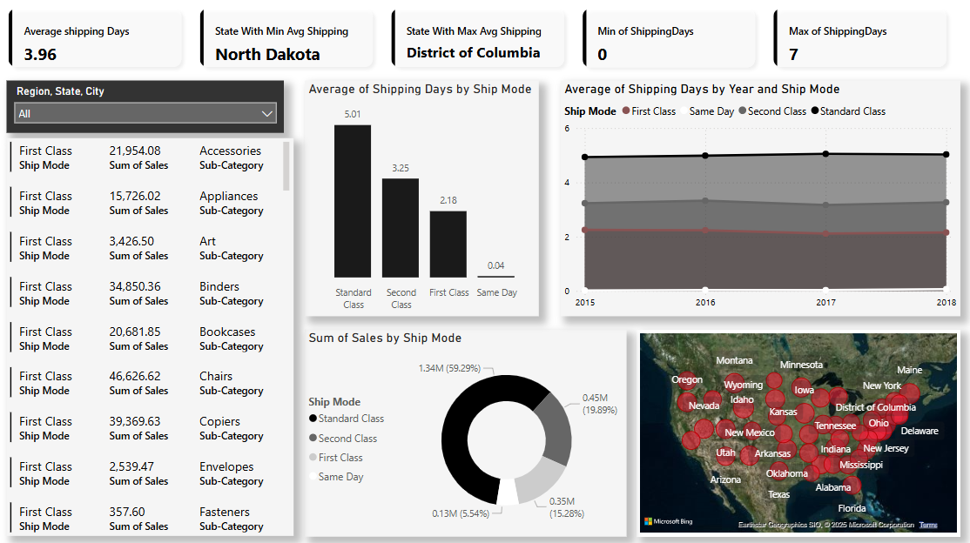

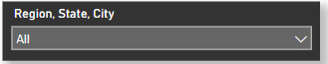

🎛️ **Filters Panel:**

* **Dropdown Filter (Region, State, City):**  
  Allows users to drill down and analyze data based on geographic location.

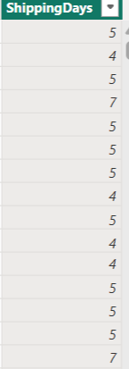

📌 **2. KPI Indicator Cards**

### 1. Shipping Days

• **Purpose:**  
To calculate the number of days taken to ship an order by subtracting the order date from the ship date. This value is used in all shipping performance KPIs.

* **Metric Logic:**

### **2. Average Shipping Days**

* **Purpose:**  
  To monitor overall shipping efficiency by calculating the average number of days taken to deliver an order.
* **Metric Logic:**
* **Insight:**  
  The current average is **3.96 days**, which shows a moderately fast shipping process. However, this can be improved further, especially when compared to Same Day or First Class shipping.

### **3. State with Minimum Average Shipping Days**

* **Purpose:**  
  Identify the best-performing state in terms of shipping speed.
* **Metric Logic:**

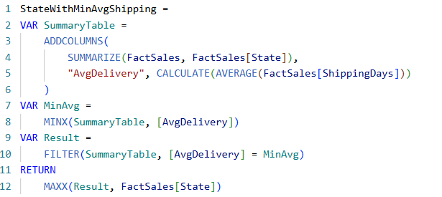

* **Insight:**  
  **North Dakota** is the fastest shipping state, which can serve as a benchmark for improving operations in other states.

### **4. State with Maximum Average Shipping Days**

* **Purpose:**  
  Highlight the state with the worst shipping performance to take corrective action.
* 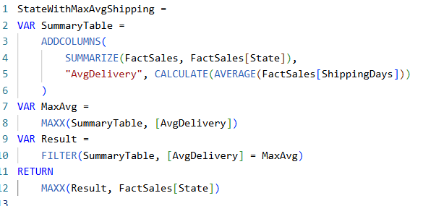**Metric Logic:**
* **Insight:**  
  **District of Columbia** has the highest average shipping time. This suggests potential logistical inefficiencies or external constraints.

### **5. Minimum Shipping Days**

* **Purpose:**  
  Track the best possible shipping duration achieved across all orders.
* **Metric Logic:**

MIN(Shipping Days)

* **Insight:**  
  The minimum is **0 days**, reflecting **Same Day** shipping. Indicates capability for immediate delivery.

### **6. Maximum Shipping Days**

* **Purpose:**  
  Identify the worst-case shipping scenario for performance evaluation.
* **Metric Logic:**

MAX(Shipping Days)

* **Insight:**  
  The max is **7 days**, which could affect customer satisfaction. Worth analyzing the orders that took this long.

### **7. Bar Chart – Average of Shipping Days by Ship Mode**

* **Purpose:**  
  Compare average shipping duration across the four shipping modes (Standard, Second Class, First Class, Same Day).
* **Insight:**
  + **Same Day:** 0.04 days – quickest, as expected.
  + **First Class:** 2.18 days – relatively fast.
  + **Second Class:** 3.25 days – moderate.
  + **Standard Class:** 5.01 days – slowest.

Businesses aiming for faster delivery may need to shift volume away from Standard Class.

### **8. Line Chart – Average of Shipping Days by Year and Ship Mode**

* **Purpose:**  
  Show trends in shipping performance for each shipping mode from 2015 to 2018.
* **Insight:**
  + Standard and Second Class show **slight increases** in shipping days.
  + First Class is **stable** around 2 days.
  + Same Day remains near 0.

This trend could indicate growing delays in the standard service over time or increased logistical load.

### **9. Donut Chart – Sum of Sales by Ship Mode**

* **Purpose:**  
  Visualize the contribution of each shipping mode to total sales.
* **Insight:**
  + **Standard Class:** $1.34M (59.29%) – dominates sales.
  + **Second Class:** $0.45M (19.89%)
  + **First Class:** $0.35M (15.28%)
  + **Same Day:** $0.13M (5.54%)

Although Standard Class is the slowest, it brings in the majority of revenue – likely due to lower cost for customers.

### **10. Map – Sales/Shipping Distribution by State**

* **Purpose:**  
  Provide geographic insight into shipping and sales performance across the U.S.
* **Insight:**  
  Quickly identifies high-performing or problematic regions.  
  E.g., **District of Columbia** stands out for highest shipping time.
* .

### 11.**Table – Sales by Sub-Category**

* **Purpose:**  
  Show detailed breakdown of sales across product sub-categories using First Class shipping.
* **Insight:**  
  Helps in identifying which product types benefit most from First Class shipping, e.g., Chairs and Copiers show high values.

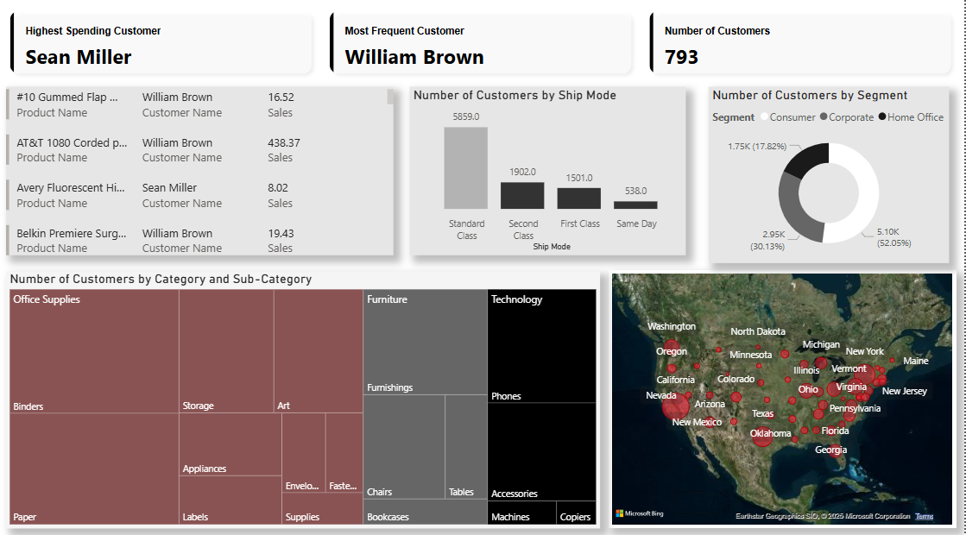

Customer Overview

#### **1. Highest Spending Customer**

* **Purpose**: Identify the customer who generated the highest total sales.
* **Metric Logic**: SUM(Sales) grouped by Customer Name and sorted descending.
* **Insight**: Sean Miller is the highest spending customer, indicating strong purchasing behavior.

#### **2. Most Frequent Customer**

* **Purpose**: Find the customer with the most frequent purchases.
* **Metric Logic**: COUNT(Orders) grouped by Customer Name.
* **Insight**: William Brown has the highest number of orders, reflecting loyalty or consistent engagement.

#### **3. Number of Customers**

* **Purpose**: Show total number of unique customers.
* **Metric Logic**: DISTINCTCOUNT(Customer Name)
* **Insight**: The dataset includes **793** unique customers.

#### **4. Number of Customers by Ship Mode (Bar Chart)**

* **Purpose**: Analyze customer count per shipping method.
* **Metric Logic**: COUNT(DISTINCT Customer Name) by Ship Mode.
* **Insight**: Standard Class is most commonly used, indicating cost-efficiency preference.

#### **5. Number of Customers by Segment (Donut Chart)**

* **Purpose**: Segment customers based on business type.
* **Metric Logic**: COUNT(DISTINCT Customer Name) by Segment.
* **Insight**: Consumers make up the majority of customers, followed by Corporate and Home Office.

#### **6. Number of Customers by Category and Sub-category (Tree Map)**

* **Purpose**: Show customer engagement across product categories.
* **Metric Logic**: COUNT(Customer Name) by Category and Sub-Category.
* **Insight**: Office Supplies dominate in terms of customer interest.

#### **7. Geographic Distribution of Customers (Map)**

* **Purpose**: Visualize customer density by state.
* **Metric Logic**: COUNT(Customer Name) by State.
* **Insight**: Higher customer concentrations in states like California, Texas, and New York.

Product Overview

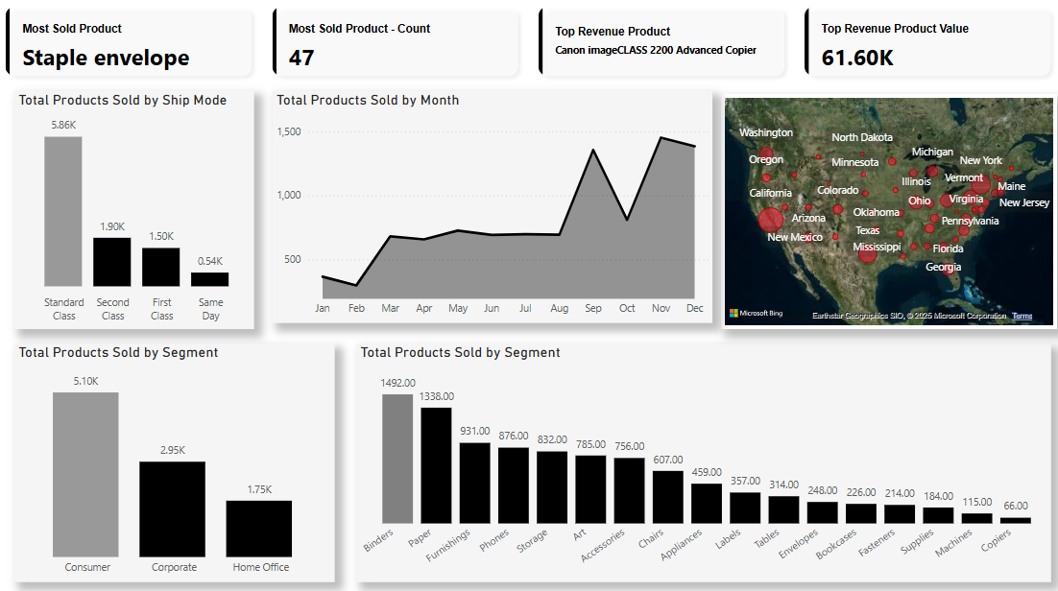

1. **Most Sold Product**
   * **Product**: Staple envelope
   * **Insight**: This product has the highest sales volume, indicating strong demand or frequent reorders.
2. **Total Products Sold by Ship Mode**
   * **Breakdown**:
     + Standard Class: 5.86K
     + Second Class: 1.90K
     + First Class: 0.54K
     + Same Day: [Value not visible]
   * **Insight**: Standard Class is the most popular shipping method, likely due to cost efficiency.
3. **Total Products Sold by Segment**
   * **Breakdown**:
     + Consumer: 5.10K
     + Corporate: 2.95K
     + Home Office: 1.75K
   * **Insight**: Consumers dominate purchases, suggesting B2C focus.
4. **Top Revenue Product**
   * **Product**: Canon ImageCLASS 2200 Advanced Copier
   * **Revenue**: 61.60K
   * **Insight**: High-ticket technology products drive significant revenue despite lower volume.
5. **Geographic Sales Distribution**
   * **States**: California, Texas, New York, and Washington show notable activity.
   * **Insight**: These regions are key markets for targeted marketing or inventory allocation.

💡 **Strategic Recommendations**

#### 1. **Leverage High Volume Products for Promotions**

* Products like **Binders, Paper, Furnishings**, and **Phones** have high movement—bundle them or offer tiered pricing to boost average order value.
* Launch seasonal discount campaigns during the **Q3/Q4 sales peaks** (Sept, Nov) to maximize returns.

#### 2. **Optimize Inventory & Logistics**

* Since **Standard Class** dominates, review shipping partnerships to reduce costs or enhance delivery speed without increasing expenses.
* Ensure regional warehouses are well-stocked in high-density states (e.g., California, Texas, Illinois) to maintain fulfillment speed.

#### 3. **Target Consumer Segment More Aggressively**

* The **Consumer segment** is the largest by volume—design personalized campaigns, loyalty programs, and retargeting ads to strengthen retention.

#### 4. **Expand Corporate Sales for Higher Margins**

* While Corporate volume is lower than Consumer, this segment tends to have higher spending capacity. Introduce B2B-exclusive offers, bulk order discounts, or invoicing options to stimulate growth.

#### 5. **Cross-Sell Lower Volume Categories**

* Encourage bundling or recommendations for underperforming categories like **Machines**, **Supplies**, and **Copiers** using AI-driven product suggestions in checkout flows.

#### 6. **Geographic Sales Strategy**

* Run **geo-targeted campaigns** in states with medium or low density but high potential (e.g., Colorado, Minnesota, Oregon), especially for back-to-school or office supply seasons.
* In high-density states, explore localized partnerships or pop-up events to deepen market presence.

#### 7. **Refine Product Positioning Using Monthly Trends**

* Monthly sales patterns show volatility—optimize digital ad spend during **peak months** and reduce it during slow periods (e.g., Jan–Feb) to maximize ROI.

Segment Overview

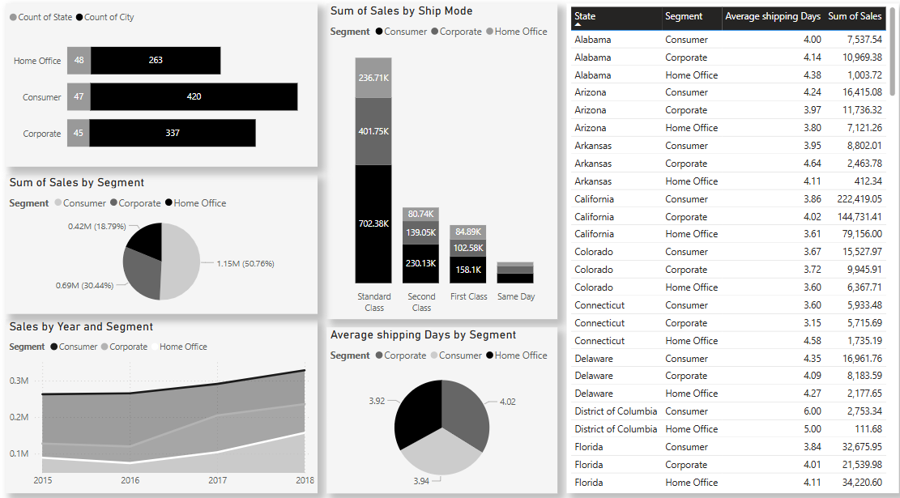

1. **Sum of Sales by Ship Mode**
   * **Breakdown**:
     + Standard Class: 25.71% (Alabama leads in Consumer segment).
   * **Insight**: Regional preferences vary; Alabama’s Consumer segment prefers Standard Class.
2. **Sum of Sales by Segment**
   * **Corporate**: 1.15M (50.76%)
   * **Consumer**: 0.42M (18.79%)
   * **Insight**: Corporate clients drive half of total sales—critical for B2B strategies.
3. **Average Shipping Days by Segment**
   * **Corporate**: 3.92 days
   * **Consumer**: 4.02 days
   * **Insight**: Minimal variation, but Corporate slightly faster—potential priority handling.

Most Sold Product (Staple envelople) Overview

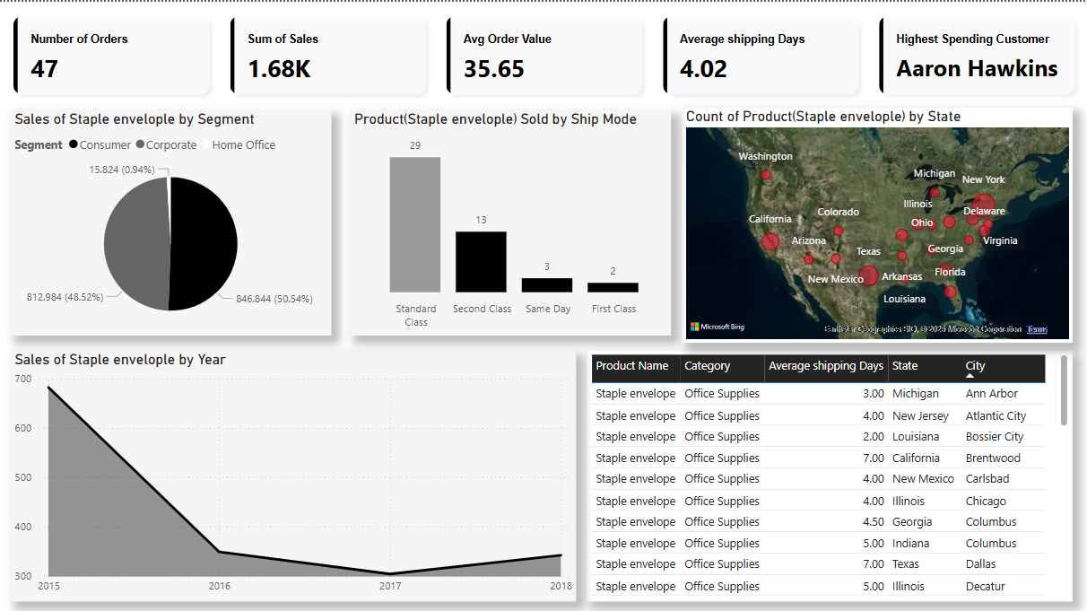

🔍 **Key Insights & Documentation**

1. **Order Overview**
   * Total Orders: **47**
   * Total Sales: **$1.68K**
   * Average Order Value: **$35.65**, indicating a low-cost, high-volume product.
   * Average Shipping Days: **4.02 Days**
   * Top Spending Customer: **Aaron Hawkins**
2. **Segment Analysis**
   * Sales are almost equally split between **Corporate (50.54%)** and **Consumer (48.52%)**, with very little contribution from Home Office (0.94%).
3. **Shipping Preferences**
   * Standard Class is the dominant shipping mode with **29 shipments**, followed by Second Class (**13**), and minor usage of Same Day and First Class.
4. **Geographic Spread**
   * Product distributed across multiple states, including **California, Texas, Georgia, and New York**, indicating strong national availability.
5. **Yearly Sales Trend**
   * Sales show a **sharp decline** from **2015 to 2017**, with a minor recovery in 2018, which might reflect market saturation or demand shift.

💡 **Strategic Recommendations**

* **Reignite Demand with Promotions:** The declining sales trend suggests a need for promotions, discount bundles, or loyalty programs to stimulate interest.
* **Focus on Corporate and Consumer Segments:** Since Home Office contribution is negligible, prioritize B2B and B2C with tailored messaging.
* **Evaluate Product Lifecycle:** Consider if the product is reaching saturation—refresh packaging or introduce eco-friendly versions to attract new customers.
* **Optimize Shipping Costs:** Since most orders use Standard Class, explore logistics partnerships or cost-saving options to improve profit margins.

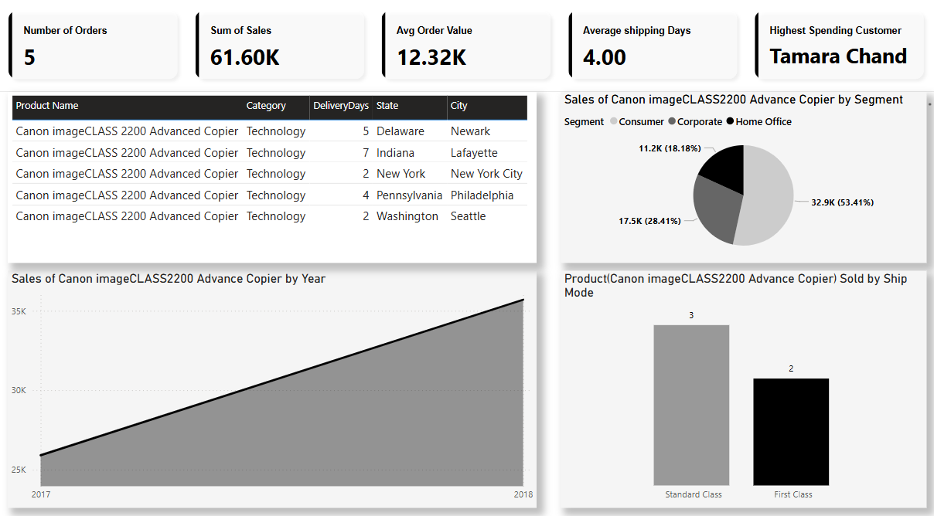

Top Revenue Product (Canon image CLASS2200 Advance Copier) Overview

🔍 **Key Insights & Documentation**

1. **Order Overview**
   * Total Orders: **5**
   * Total Sales: **$61.6K**
   * Average Order Value: **$12.32K**, indicating high-value transactions.
   * Average Shipping Days: **4.00 Days**
   * Top Spending Customer: **Tamara Chand**
2. **Sales by Geography**
   * Product sold across **5 States** and **5 Cities**, including major hubs like New York City and Philadelphia.
3. **Segment Analysis**
   * Majority of sales come from **Corporate segment (53.41%)**, followed by **Home Office (28.41%)** and **Consumer (18.18%)**.
4. **Ship Mode**
   * Standard Class dominates with **3 shipments**, and First Class used for **2 shipments**.
5. **Yearly Sales Trend**
   * Strong positive growth from **2017 to 2018**, with an increase of more than **$10K** in sales, suggesting growing product demand.

💡 **Strategic Recommendations**

* **Target Corporate Buyers:** With over half of sales coming from the corporate segment, tailor marketing efforts and service packages specifically for enterprise clients.
* **Expand to Similar Urban Markets:** Current cities like NYC and Philadelphia show strong performance—consider targeting similar metro areas with high office density.
* **Premium Service Upsell:** Leverage the high AOV and pitch First Class shipping with added support or faster delivery options for premium corporate customers.
* **Explore Product Bundling:** High order value indicates interest in advanced tech—bundle with accessories or services to increase value further.
* **Monitor Inventory for Growth:** As year-over-year sales are rising, maintain or scale inventory levels to match this upward trend.